POS Lanes Automation Execution Guide

Prerequisites
Before executing the automation script, ensure the following software and tools are installed and configured.
1. Download TRCConsole
The automation requires the TRCConsole application to connect to the target system.
Steps
- Download TRCConsole.jar from the SharePoint link below:
Download Link:
ADUSA IT Quality Assurance & Testing - Documents - Automation - All Documents
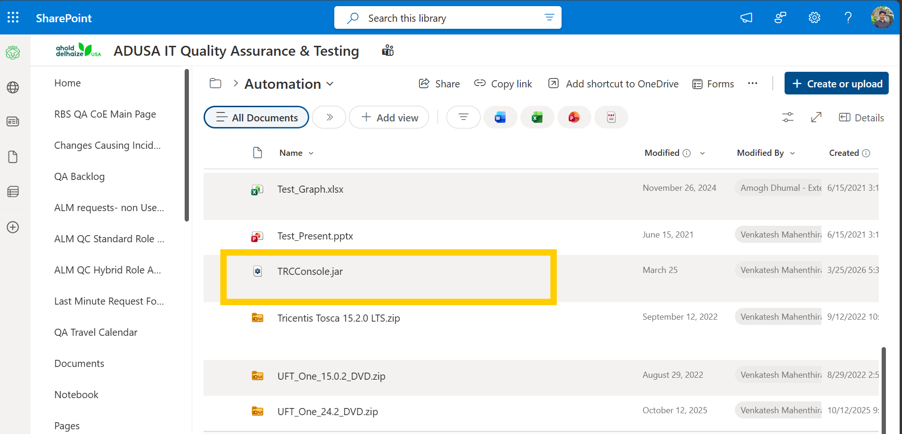

- Save the file to a local folder (Example: C:\TRCConsole\).
- Ensure the file is accessible and not blocked by Windows security settings.

2. Install Java
TRC Console requires Java to run.
Recommended Version: Java 8
Installation Steps
- Download Java from the approved source:
Download Link: Eclipse Temurin JDK 8 Downloads
- Run the installer.
- Follow the installation wizard and complete the setup.
- Verify Java installation:
  - Open Command Prompt.
  - Run the command: java -version
- Confirm that the installed Java version is displayed successfully.
Example Output
java version "1.8.0_xxx"
If the version is displayed, Java installation is complete.

3. Install UFT (Unified Functional Testing)
UFT is required to execute the automation scripts.
Steps
- Download UFT from the approved source:
Download Link: UFT_One_24.2_DVD
- Run the installer.
- Complete the installation using default settings unless instructed otherwise.
- Launch UFT and verify that it opens successfully.
Notes
- Ensure the UFT license is activated.

Script Setup and Execution
1. Download Automation Script
- Clone or download the latest automation script from the Git repository.
Repository: BanuchandhiranM/POS_Lanes_Automation
- Save the project to a local folder.
Example:
C:\Automation\POS_Automation\

2. Open the Project in UFT
- Launch UFT One.
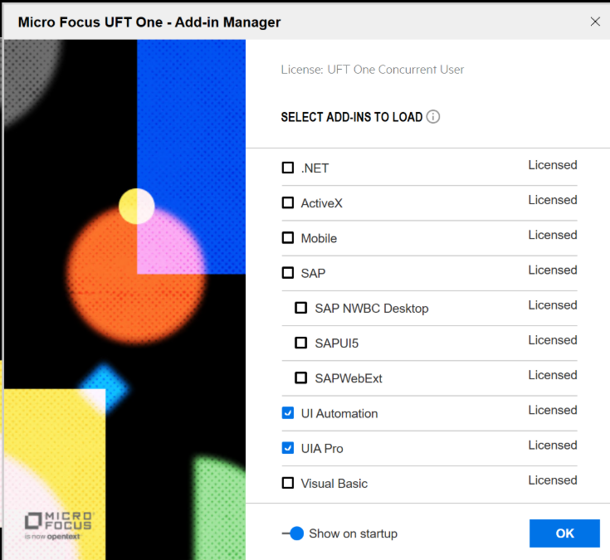

- In the Add-in Manager, select UI Automation and UIA Pro, and then click OK to proceed.
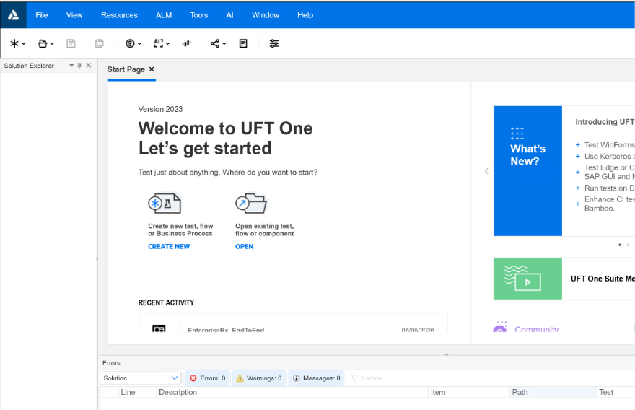

- Open the downloaded project from the local repository.

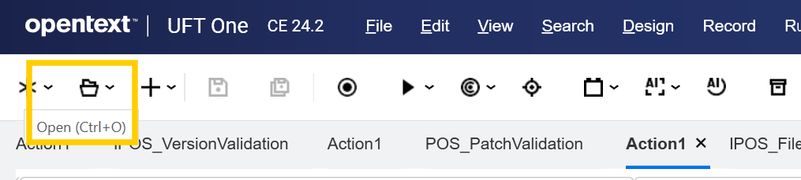

- Click on open icon or Ctrl+O
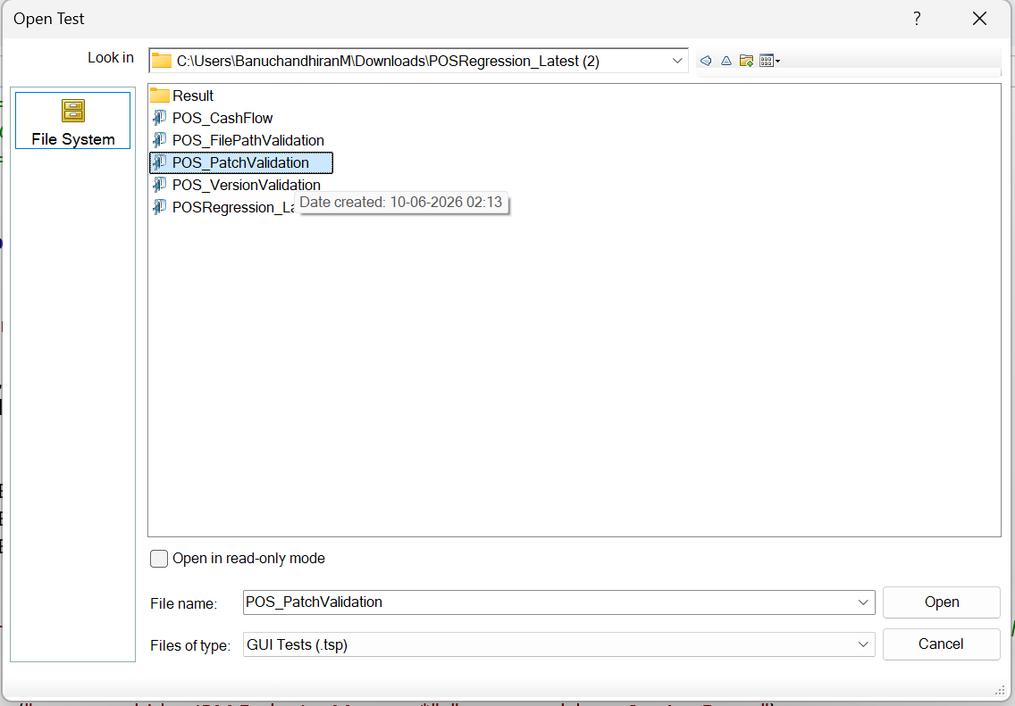
- Select the project and click ‘Open’
- Verify that all actions are visible in the Solution Explorer and that the script opens successfully.
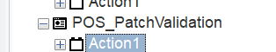

Verify Login Test Data
Open: POS_Lanes_TestData.xlsx and Navigate to the LoginData sheet.
Ensure the following values are entered before execution:
Parameter Name | Description
laneAddress | Lane address to be validated
userId | User VNID
userPassword | User password
domainName | Domain name(Delhaize)
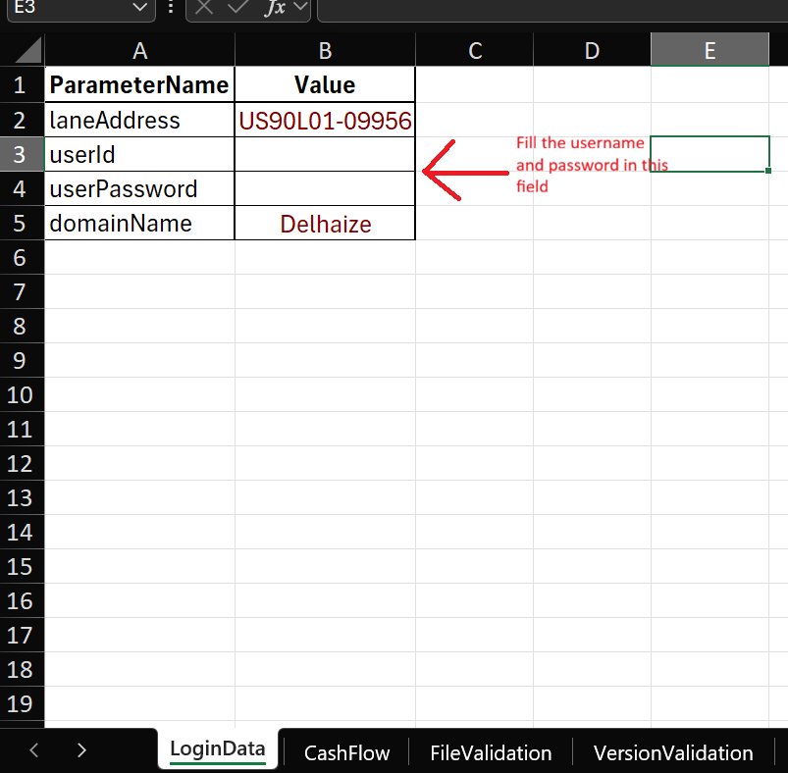
Important: The script will fail to authenticate if the User ID or Password fields are left blank.

Update Local Paths

Patch Validation:-
Once the script is loaded, update the highlighted paths to match your local machine setup before execution.
Excel Test Data Path
Locate the following line:
excelPath = "C:\Users\BanuchandhiranM\Lanes\POS_Lanes_TestData.xlsx"
Update it with the actual location of the test data file on your machine.

TRC Console Path
Locate the following line:
WshShell.Run "javaw -jar ""C:\Users\BanuchandhiranM\Downloads\TRCConsole.jar""", 1, False
Update it with the location where TRCConsole.jar was downloaded.

Screenshot Storage Path
If a different location is preferred, update the path in the script accordingly.

Verify Test Data
Open: POS_Lanes_TestData.xlsx and Navigate to the PatchValidation sheet.
This sheet contains the list of HotFix IDs that will be validated against the lane during execution.
Validation Before Execution
- Ensure the latest and correct HotFix IDs are populated before execution
- Do not modify the column headers.
- Do not manually update the Status column.
- Verify there are no blank rows between HotFix entries.
Expected Result
After successful execution:
- The automation validates each HotFix ID against the lane.
- The Status column is automatically updated with:
  - PASS – HotFix found on the lane.
  - FAIL – HotFix not found on the lane.

File Path Validation:-
Once the script is loaded, update the highlighted paths to match your local machine setup before execution.

Excel Test Data Path
Locate the following line:
excelPath = "C:\Users\BanuchandhiranM\Lanes\POS_Lanes_TestData.xlsx"
Update it with the actual location of the test data file on your machine.

TRC Console Path
Locate the following line:
WshShell.Run "javaw -jar ""C:\Users\BanuchandhiranM\Downloads\TRCConsole.jar""", 1, False
Update it with the location where TRCConsole.jar was downloaded.

Test Evidence Path

Update the Test evidence word document path as per the local

Screenshot Storage Path
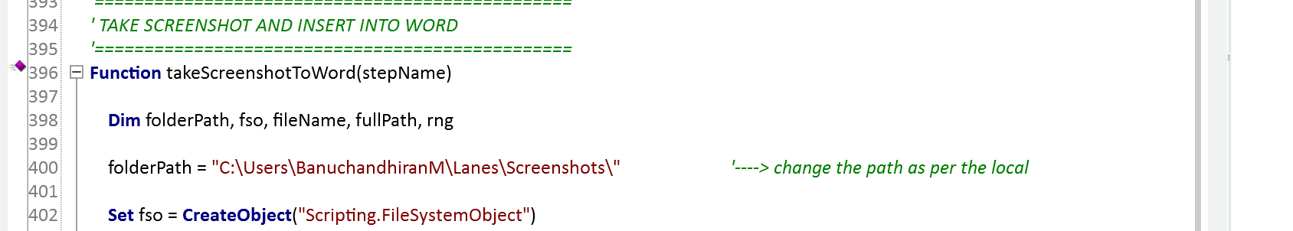
Update the Screenshot path as per the local
If a different location is preferred, update the path in the script accordingly.

Verify Test Data
Open: POS_Lanes_TestData.xlsx and Navigate to the FileValidation sheet.
This sheet contains the list of files and file locations that will be validated on the target lane during execution.
Validation Before Execution
- Ensure all required file paths are populated in the fileLocation column.
- Ensure all required file names are populated in the fileName column.
- Do not modify the column headers.
- Do not manually update the Status or Remarks columns.
- Verify there are no blank rows between file entries.
Expected Result
After successful execution:
- The automation verifies whether each file exists in the specified location.
- The Status column is automatically updated with:
PASS – File found in the specified location.
FAIL – File not found in the specified location.

Cash Flow Validation: -
Once the script is loaded, update the highlighted paths to match your local machine setup before execution.
Excel Test Data Path
Locate the following line:
excelPath = "C:\Users\BanuchandhiranM\Lanes\POS_Lanes_TestData.xlsx"
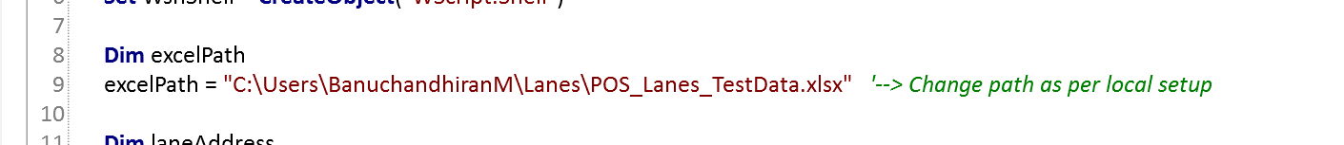
Update it with the actual location of the test data file on your machine.

TRC Console Path
Locate the following line:
WshShell.Run "javaw -jar ""C:\Users\BanuchandhiranM\Downloads\TRCConsole.jar""", 1, False
Update it with the location where TRCConsole.jar was downloaded.

Test Evidence
The screenshots and supporting execution evidence are automatically saved to the configured local path specified in the script.
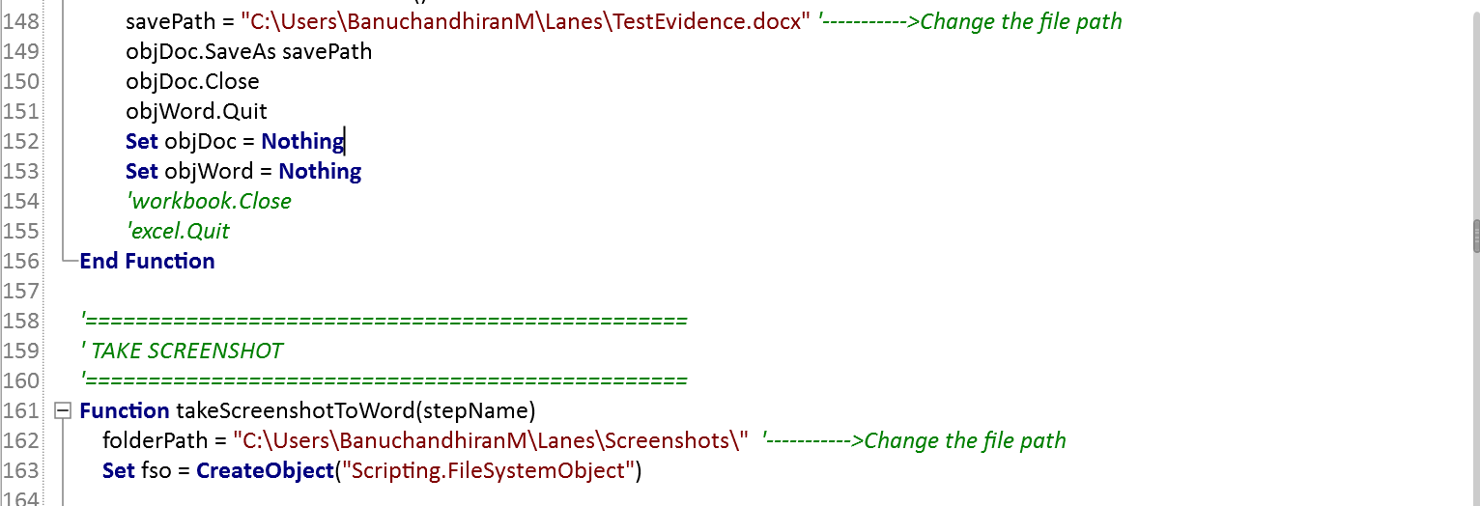
Change the Document path and Screenshot path as per local.

Open: POS_Lanes_TestData.xlsx and Navigate to the CashFlow sheet.

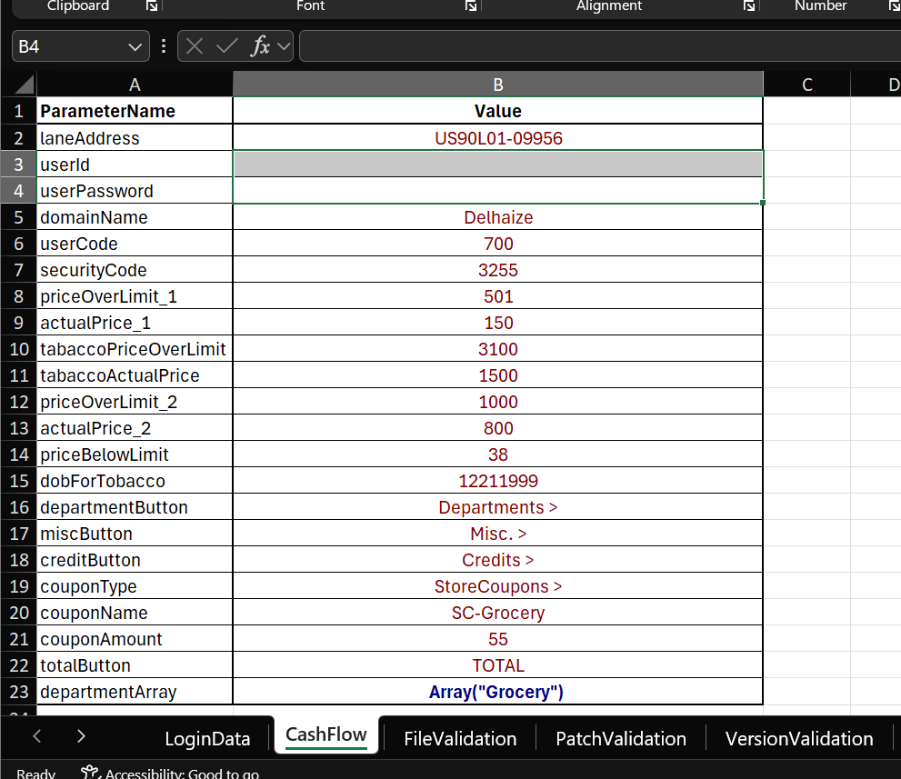

This sheet contains all input data required for Cash Flow validation. The automation uses these values to perform transaction processing, price validations, age-restricted item validations, coupon validations, and payment validations on the lane.

Validation Before Execution
- Verify that all mandatory fields are populated.
- Maintain the existing format of the sheet.

Expected Result
After successful execution, the automation will:
- Login to the lane.
- Perform Cash Flow transaction validations.
- Validate approval-required price overrides.
- Validate tobacco age verification scenarios.
- Validate coupon processing.
- Validate payment and transaction completion.
- Generate Test evidence for each validation step.

Version Validation: -
Once the script is loaded, update the highlighted paths to match your local machine setup before execution.
Excel Test Data Path
Locate the following line:
excelPath = "C:\Users\BanuchandhiranM\Lanes\POS_Lanes_TestData.xlsx"
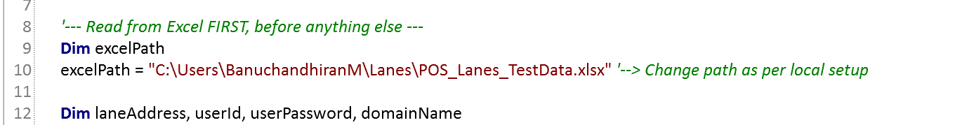
Update it with the actual location of the test data file on your machine.

TRC Console Path
Locate the following line:
WshShell.Run "javaw -jar ""C:\Users\BanuchandhiranM\Downloads\TRCConsole.jar""", 1, False
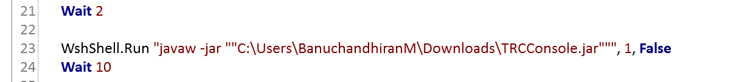
Update it with the location where TRCConsole.jar was downloaded.

Open: POS_Lanes_TestData.xlsx and Navigate to the VersionValidation sheet.
This sheet contains the list of applications, drivers, services, and software components whose versions must be validated on the target lane.
The automation compares the installed version on the lane against the expected version specified in the Excel sheet.
Validation Before Execution
- Ensure all required applications and components are listed.
- Verify that the ExpectedVersion column contains the correct version numbers.
- Do not modify the column headers.
Expected Result
After successful execution, the automation will:
Update the Status column with:
  - PASS – Installed version matches the expected version.
  - FAIL – Installed version does not match the expected version.

Start Script Execution
Click the Run button from the UFT toolbar.
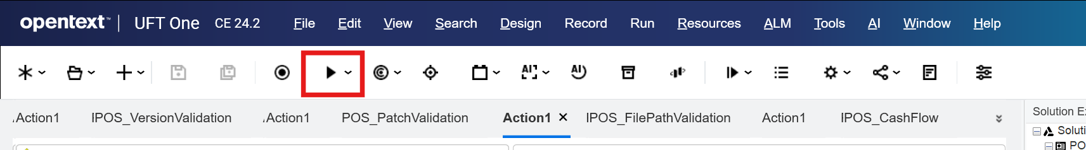
This will open the Run dialog window.

Select Result Location
In the Run dialog:
- Select Temporary run results folder.
- Click Run.
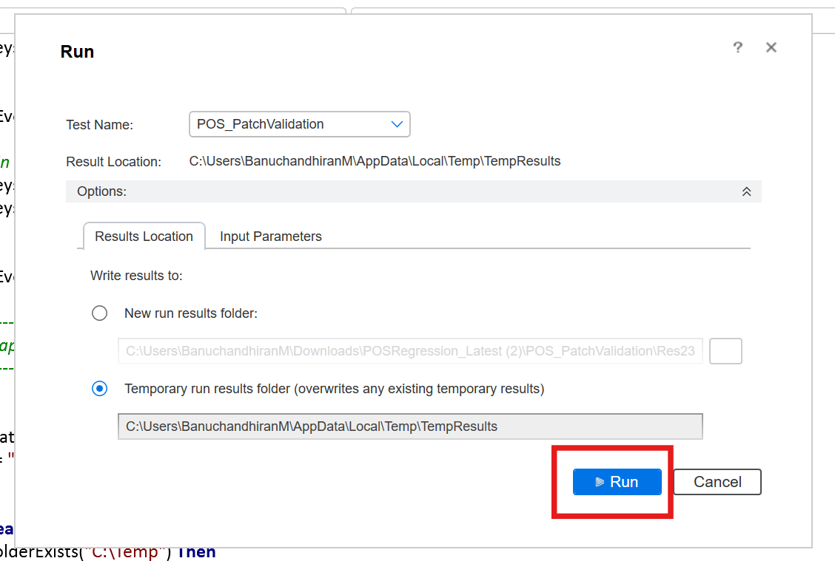

The automation execution will start.

